Sayem Chowdhury

CSE 2110: Computer Science I

Programming Project

Subject: Test Plan

Date: December 02, 2017

**Project Test Plan**

This project is made to control the car dealership system by an employee who worked at car dealership. At the time of the program execution the program will display a menu option to the employee, by using this menu option employee of the dealership will apply necessary operation in the dealership system such as search inventory, add car, sell car, display catalog etc. as needed to run the business of dealership.

**Test Plan Goal:**

The goal of the test plan is to make sure that program execute successfully and perform desired operations as project requirements and also handle all kind of exceptions that can do an unexpected program termination without fulfilling user requirements. Also, if any exception, error or bugs is found during program testing, necessary code will be written to solve the problem.

**Test Strategy :**

In the testing process, first I test my menu and then I go through all the menu options and test all the function I used for each menu options. At the time of testing I will make sure that functions are worked properly and fulfilling each options requirements. Also, I tested for exceptions by putting wrong input to make sure that function are able to handle unexpected input from the user.

**Test Execution:**

**Testing Menu Option:**

At time of program run, it displays a menu option for user. Using this menu option user will maintain car dealership.

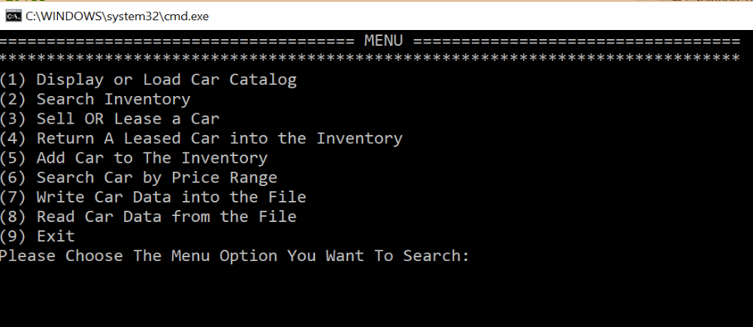

First I choose one of menu option and figured out it works. Also, I enter wrong input for menu option to make sure that menu option is able to handle this exception and give chance to the user repeatedly to choose correct option.

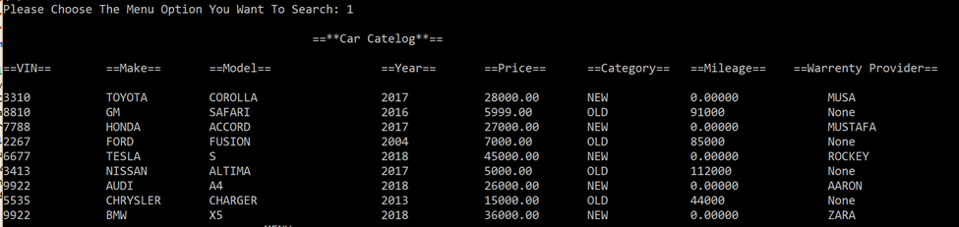

There is exception handler with appropriate message when user choose wrong menu option and the exception handler repeatedly give the user to choose right option.

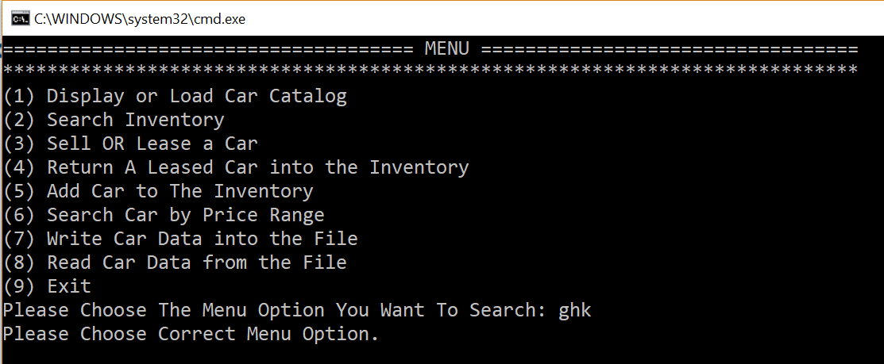

**Testing Displaying or Loading Catalog Option:**

After display the menu option when I choose the option 1, to load it successfully load the catalog which included both old and new car.

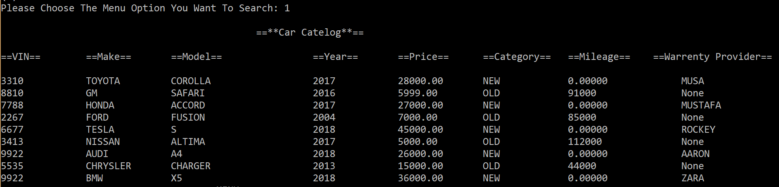

**Testing Search Inventory option:**

The search option will give the user three option to choose search by make, search by model and search by category option. I tested all those three option and got the expected search result from each search option.

**Search by model:**

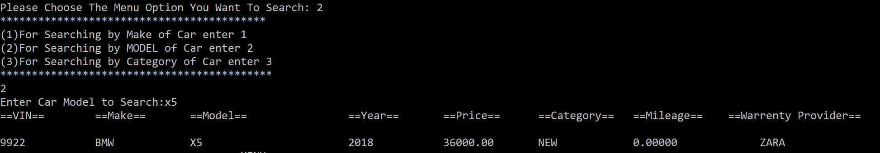

**Search by make:**

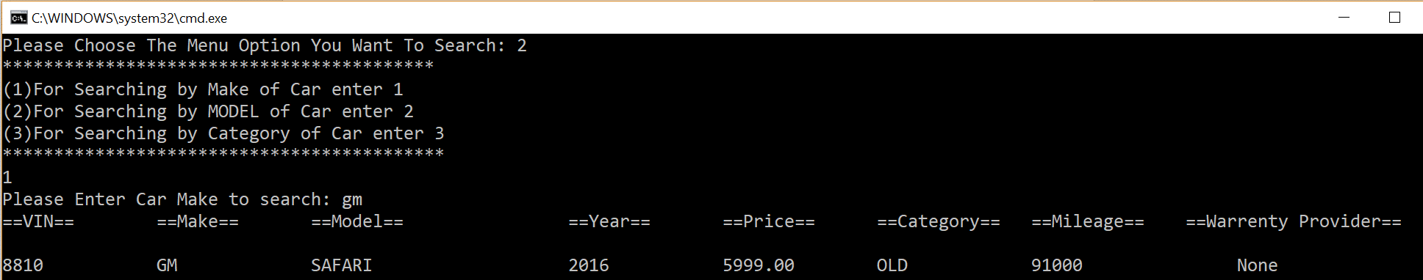

**Search by category:**

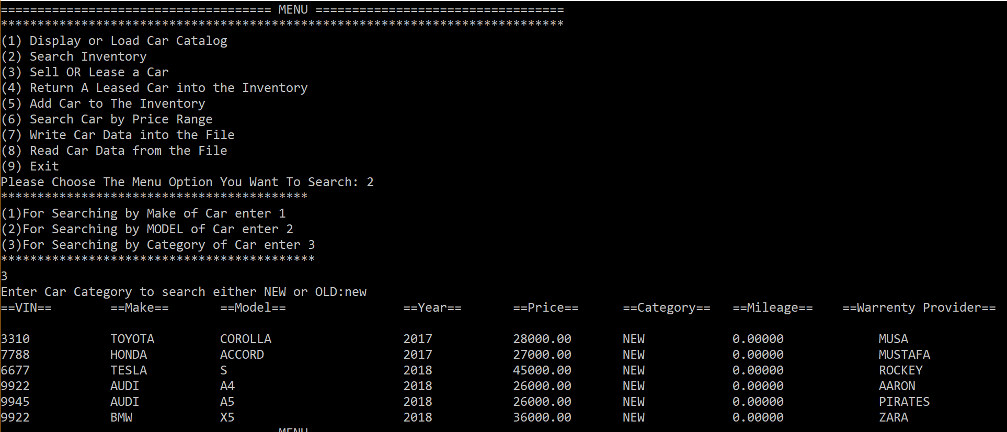

If user choose wrong search option its returning appropriate message and repeatedly give chance to choose correct search option.

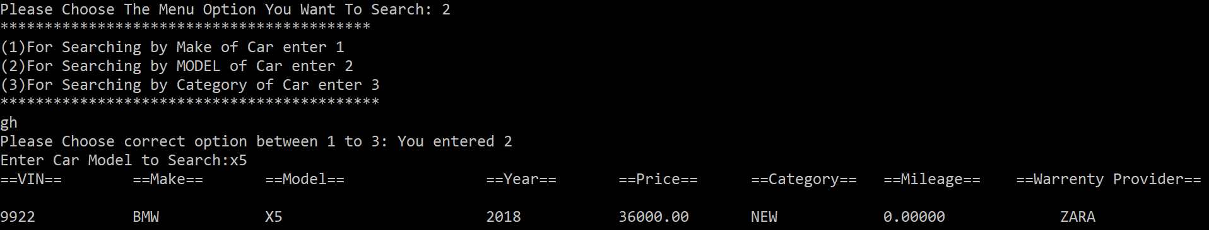

**Testing Sell or Lease car option:**

User can sell or lease a car by VIN number of the Car. After selling or leased car the car data will be disappear from the catalog. To make sure the car that the sell or lease car disappear from the catalog I choose option 1 again to see the catalog.

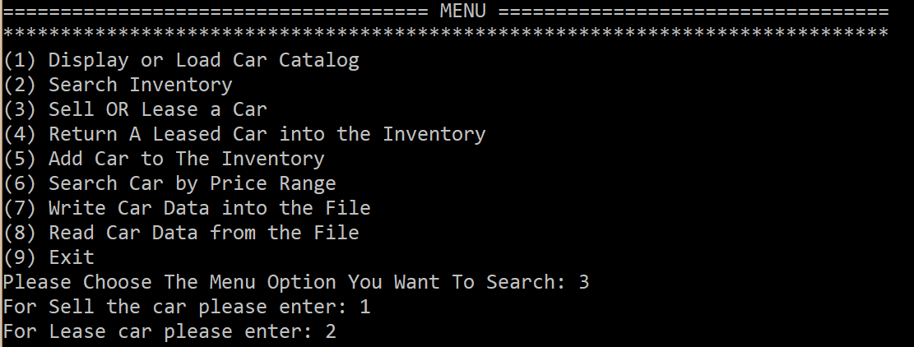

**Confirming the user the car sold successfully:**

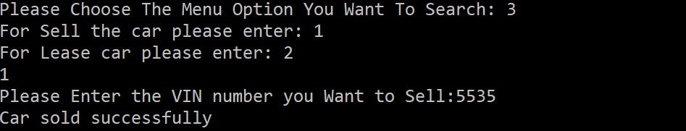

**The sold car 5535 is disappear from the list.**

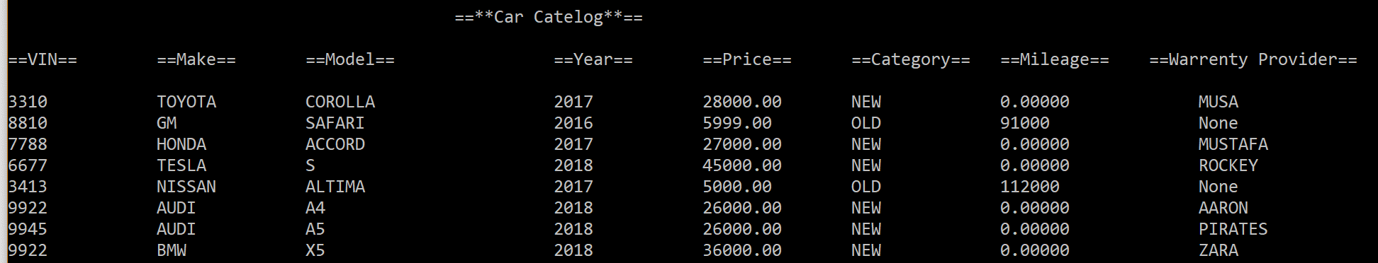

**Confirming user Lease car successfully:**

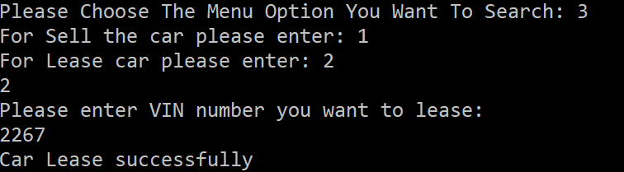

The leased car 2277 is diapered from the list.

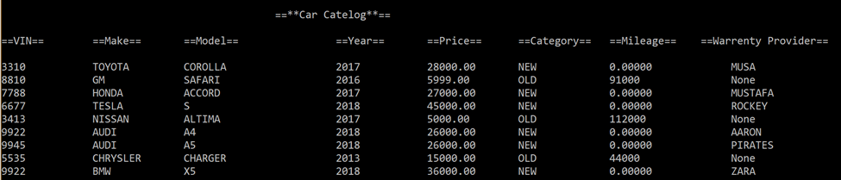

I also input wrong input to make sure that function handling exception.

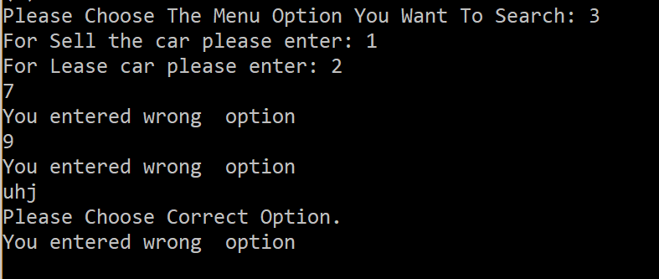

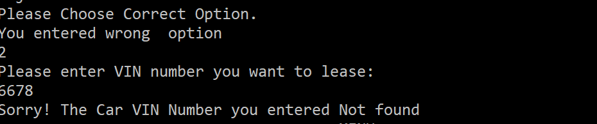

**Testing Add car option:**

By using option 5 user will able to add new or old car to the inventory.

After adding car to the inventory user are able to check the catalog to make sure that added car is displaying in the catalog.

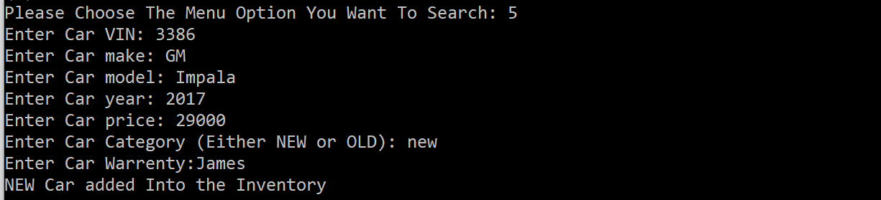

Screenshot below showing added car displaying in the inventory:

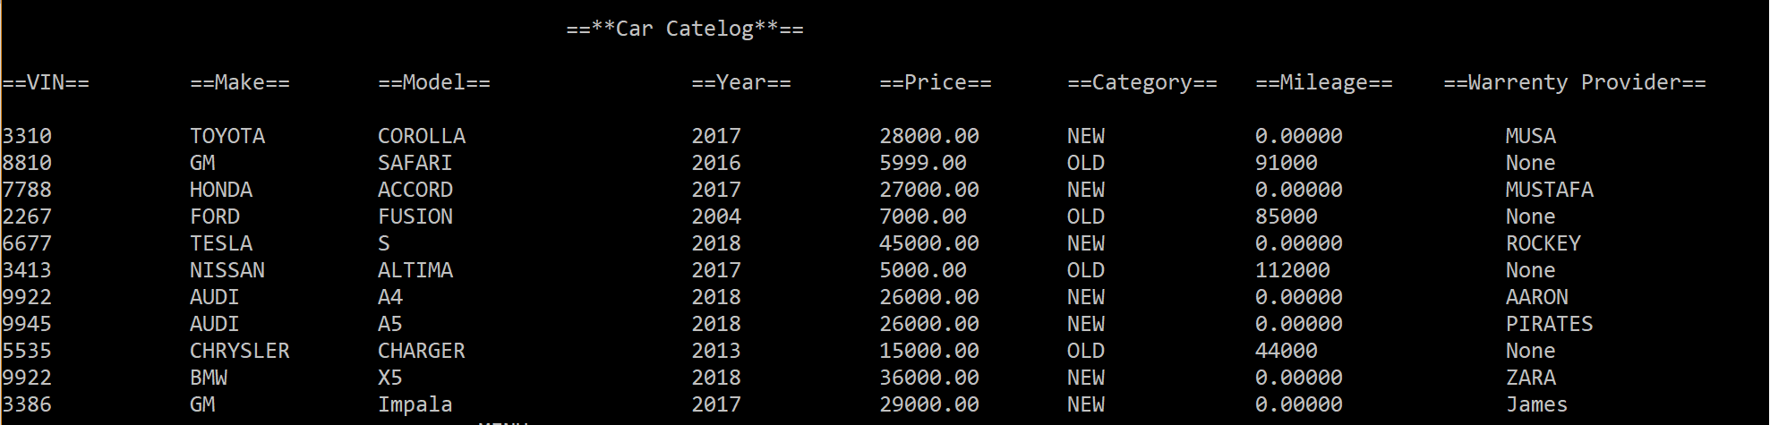

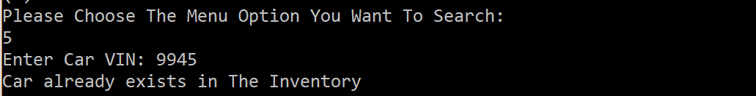

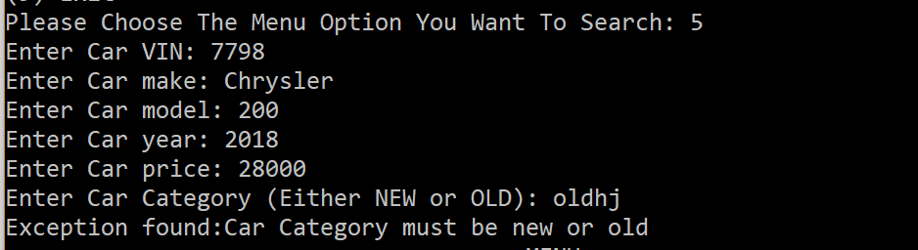

**Search by Price range:**

At the time of testing this option I enter a upper price range and a lower price range.

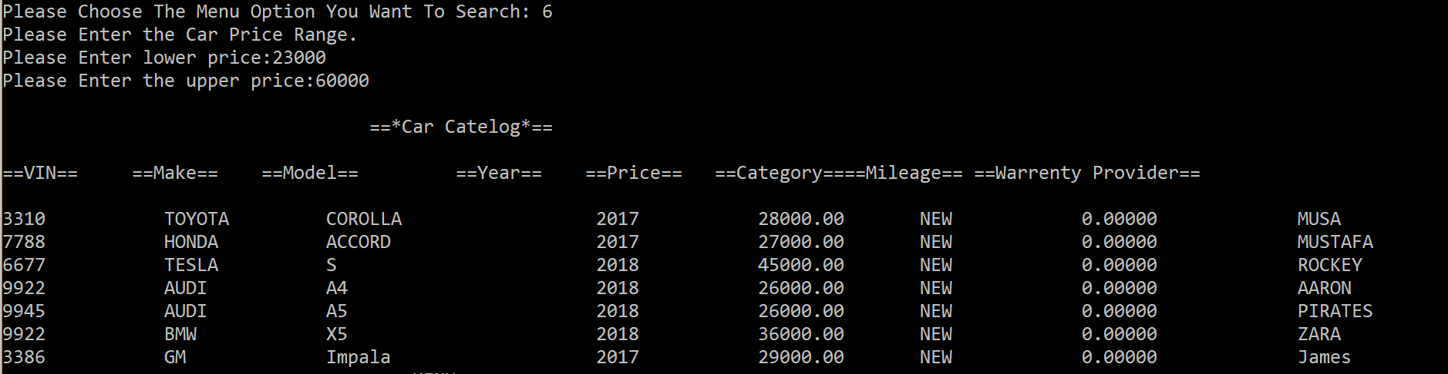

**Testing Write Data Option:**

For writing data I enter option 7 and it displayed appropriate message to confirm car data is written in the file that I opened.

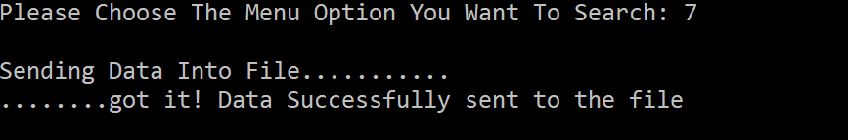

The data that written in the file.

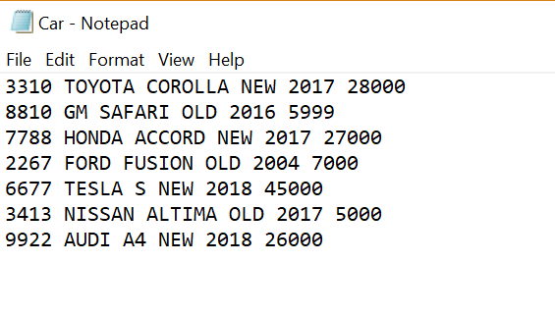

**Testing Read data:**

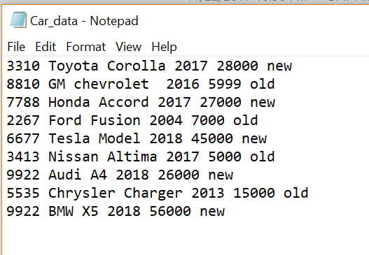

The car data will be read from the above file.

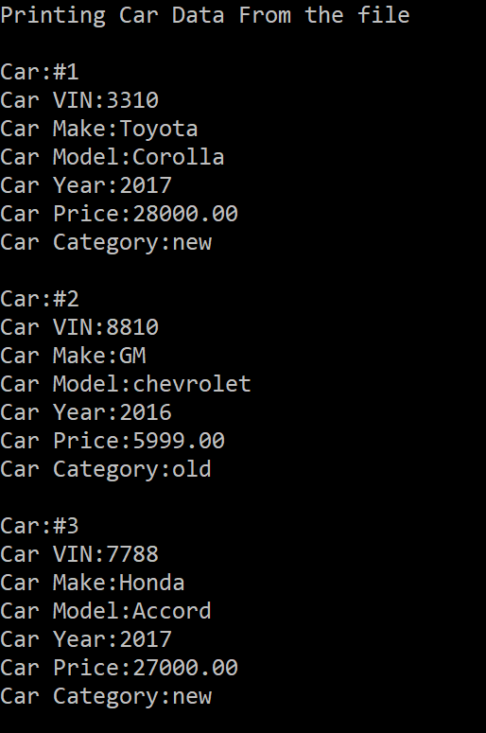

…….

…….

**Testing Exit Option:**

For the exit option I entered 9 and successfully able to exit from the menu.

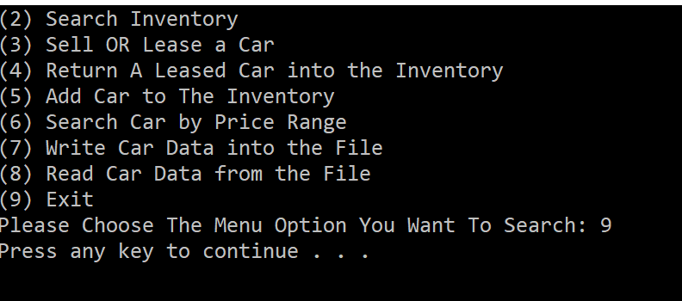

**Test Result:**

The result of the test is very satisfied. The program is able to perform all required operations of the project using functions and able to handle all kind of unexpected situations or exceptions. At time of testing I also found couple of exception, and writing appropriate code I had fixed those exception.